  - August/Setember 2019
LAKESHORE
CHRISTIAN
EXPERIENCE
WEEKEND
The Next 25 Years
A New Beginning
And A New Opportunity
To Light A New Fire

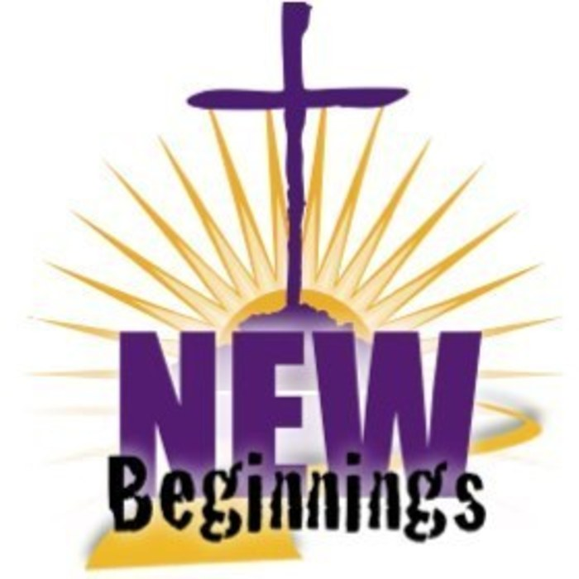

THE CEW Spirit
  - Notes from the director…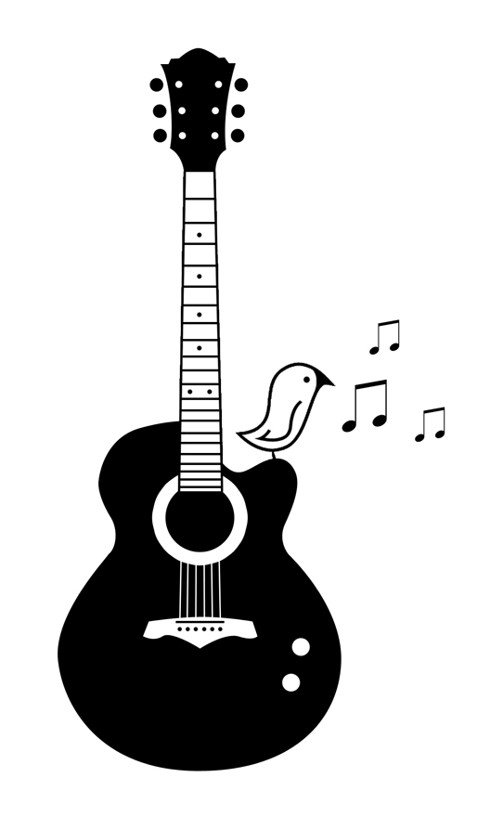
  - BIG BIG NEWS!!!!!!! Thanks to some awesome visionaries and the movements of the Holy Spirit, the next round of women and men CEWs are going to be held at the former “sister’s residence” at Roncalli H.S. This space creates all kinds of great opportunities for us as a community to welcome sisters and brothers to join us as we pursue a new life in Christ. I have to admit that when this proposal was presented to the CORE and myself I was less than enthusiastic about it but as time went on I opened my eyes to all that this new location has to offer. One grace is to be in a setting that is more neutral and thus we can live out our name of “Lakeshore” CEW. Another grace is the excitement of creating new visions and new possibilities that haven’t been experienced since the first days of CEW some 25 years ago. A third grace is that the building is much more accessible and comfortable for folks of all mobility levels with shorter walks and the only time necessary to go up stairs will be to go to bed….Wait did I say beds? Yes we should be able to facilitate a bed for most if not all candidates with team sharing a smaller space with candidates on some other sleeping arrangement (single air mattress, newer cots etc.) and a private shower for every two rooms. I could go on and on but I suggest you come and see for yourself. It certainly is time to begin praying for and inviting folks to our upcoming weekends. It is a new beginning, a new opportunity for us to light a new fire in our community and throughout the “lakeshore.” Blessings: Deacon Rich

  - Prayerful thoughts from our upcoming Rector
  - 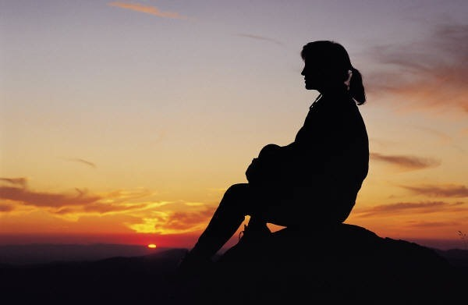
  - Dear Family in Christ, The last few months have been exhausting…and EXCITING! After much head-scratching and prayer, we as CEW Core and past rectors have decided to change the venue for the upcoming Women’s CEW and for all CEWs in the future. We will be converting the sister’s residence at Roncalli H.S. into a retreat house. It has been wonderful to work with all of you. I have had such guidance and help which has definitely made the process easier. I know some of you may have concerns, as do I, but together we will make this work for the good of the gospel. My utmost dream is to be leading a group of women closer to God through His Son Jesus Christ while being strengthened myself. I am well on my way to discovering my team and can hardly believe that in 3 short months we will be filling those 16 bedrooms with women that will become part of our lives forever. Karen Cisler has posted some picture on the CEW website but I have also attached a few of my own. I am asking for prayers as this idea becomes a reality and welcome your input and constructive criticism. Let’s all work together for the common good!
  - Jody Gauthier 2019 Women’s Rector

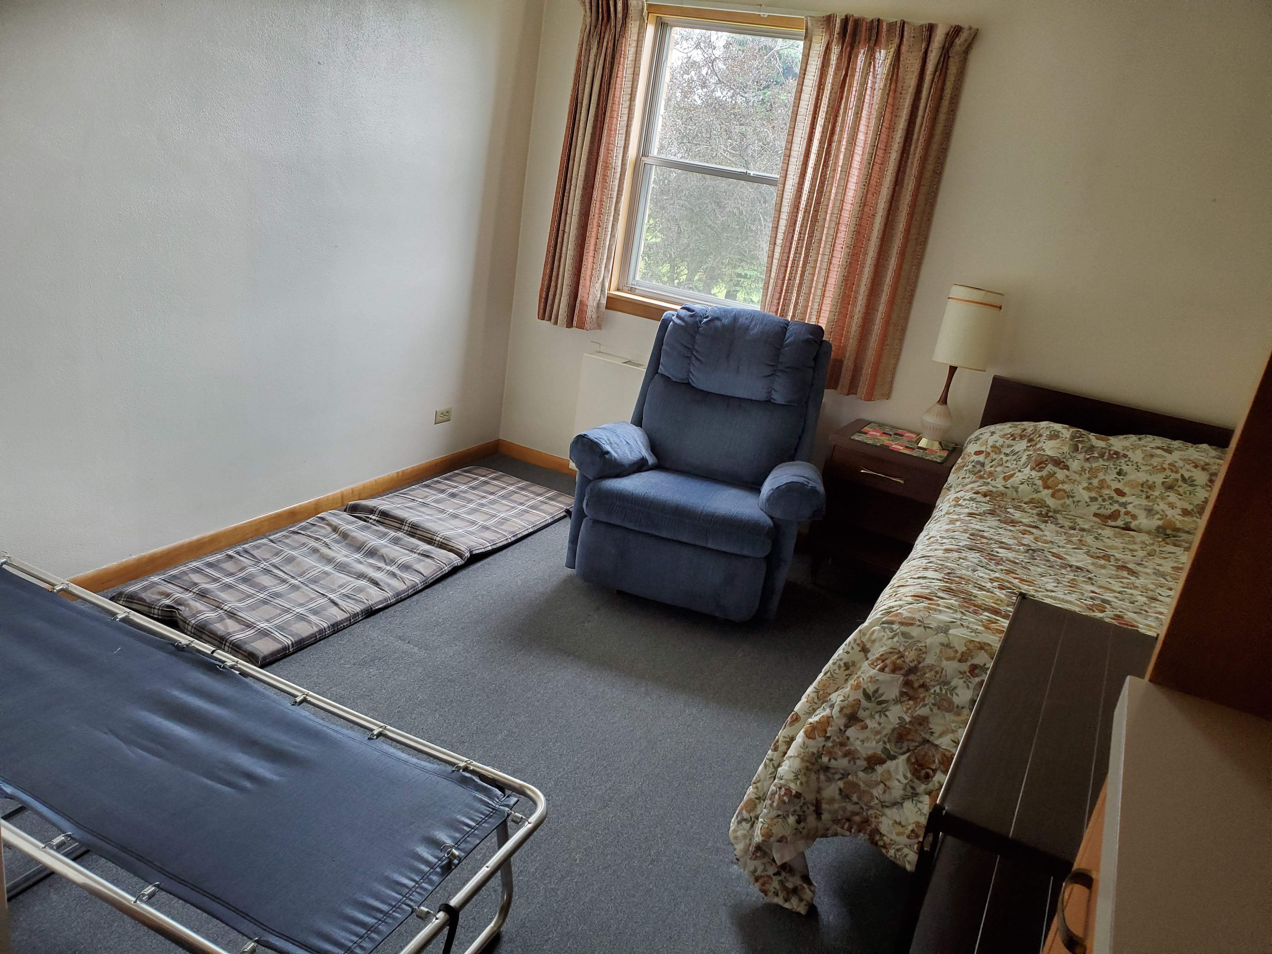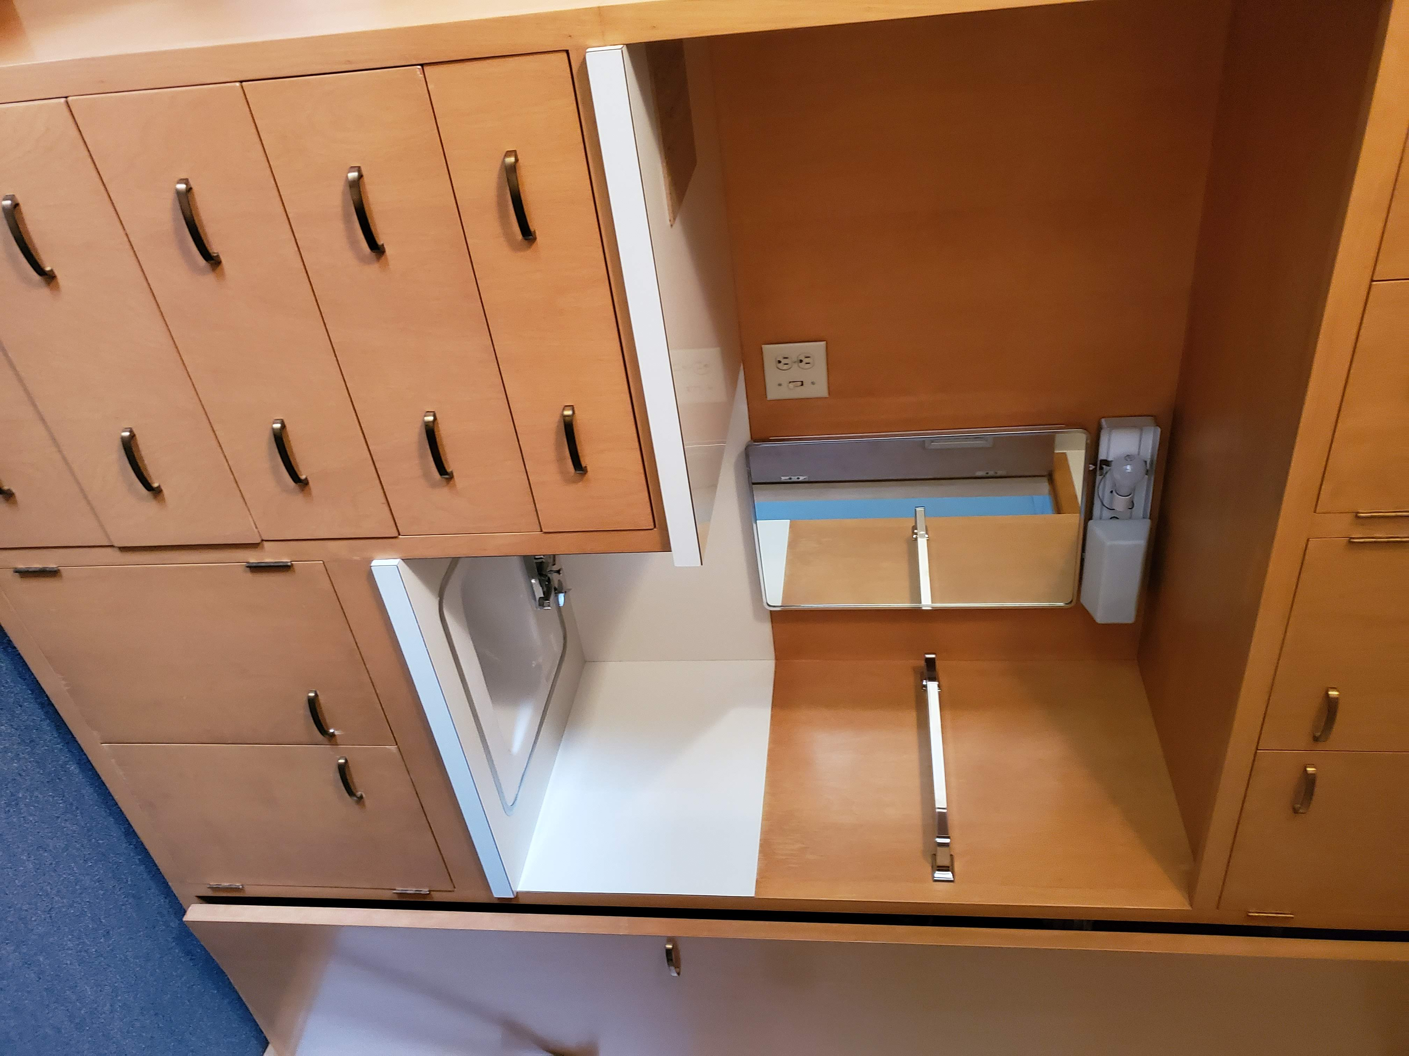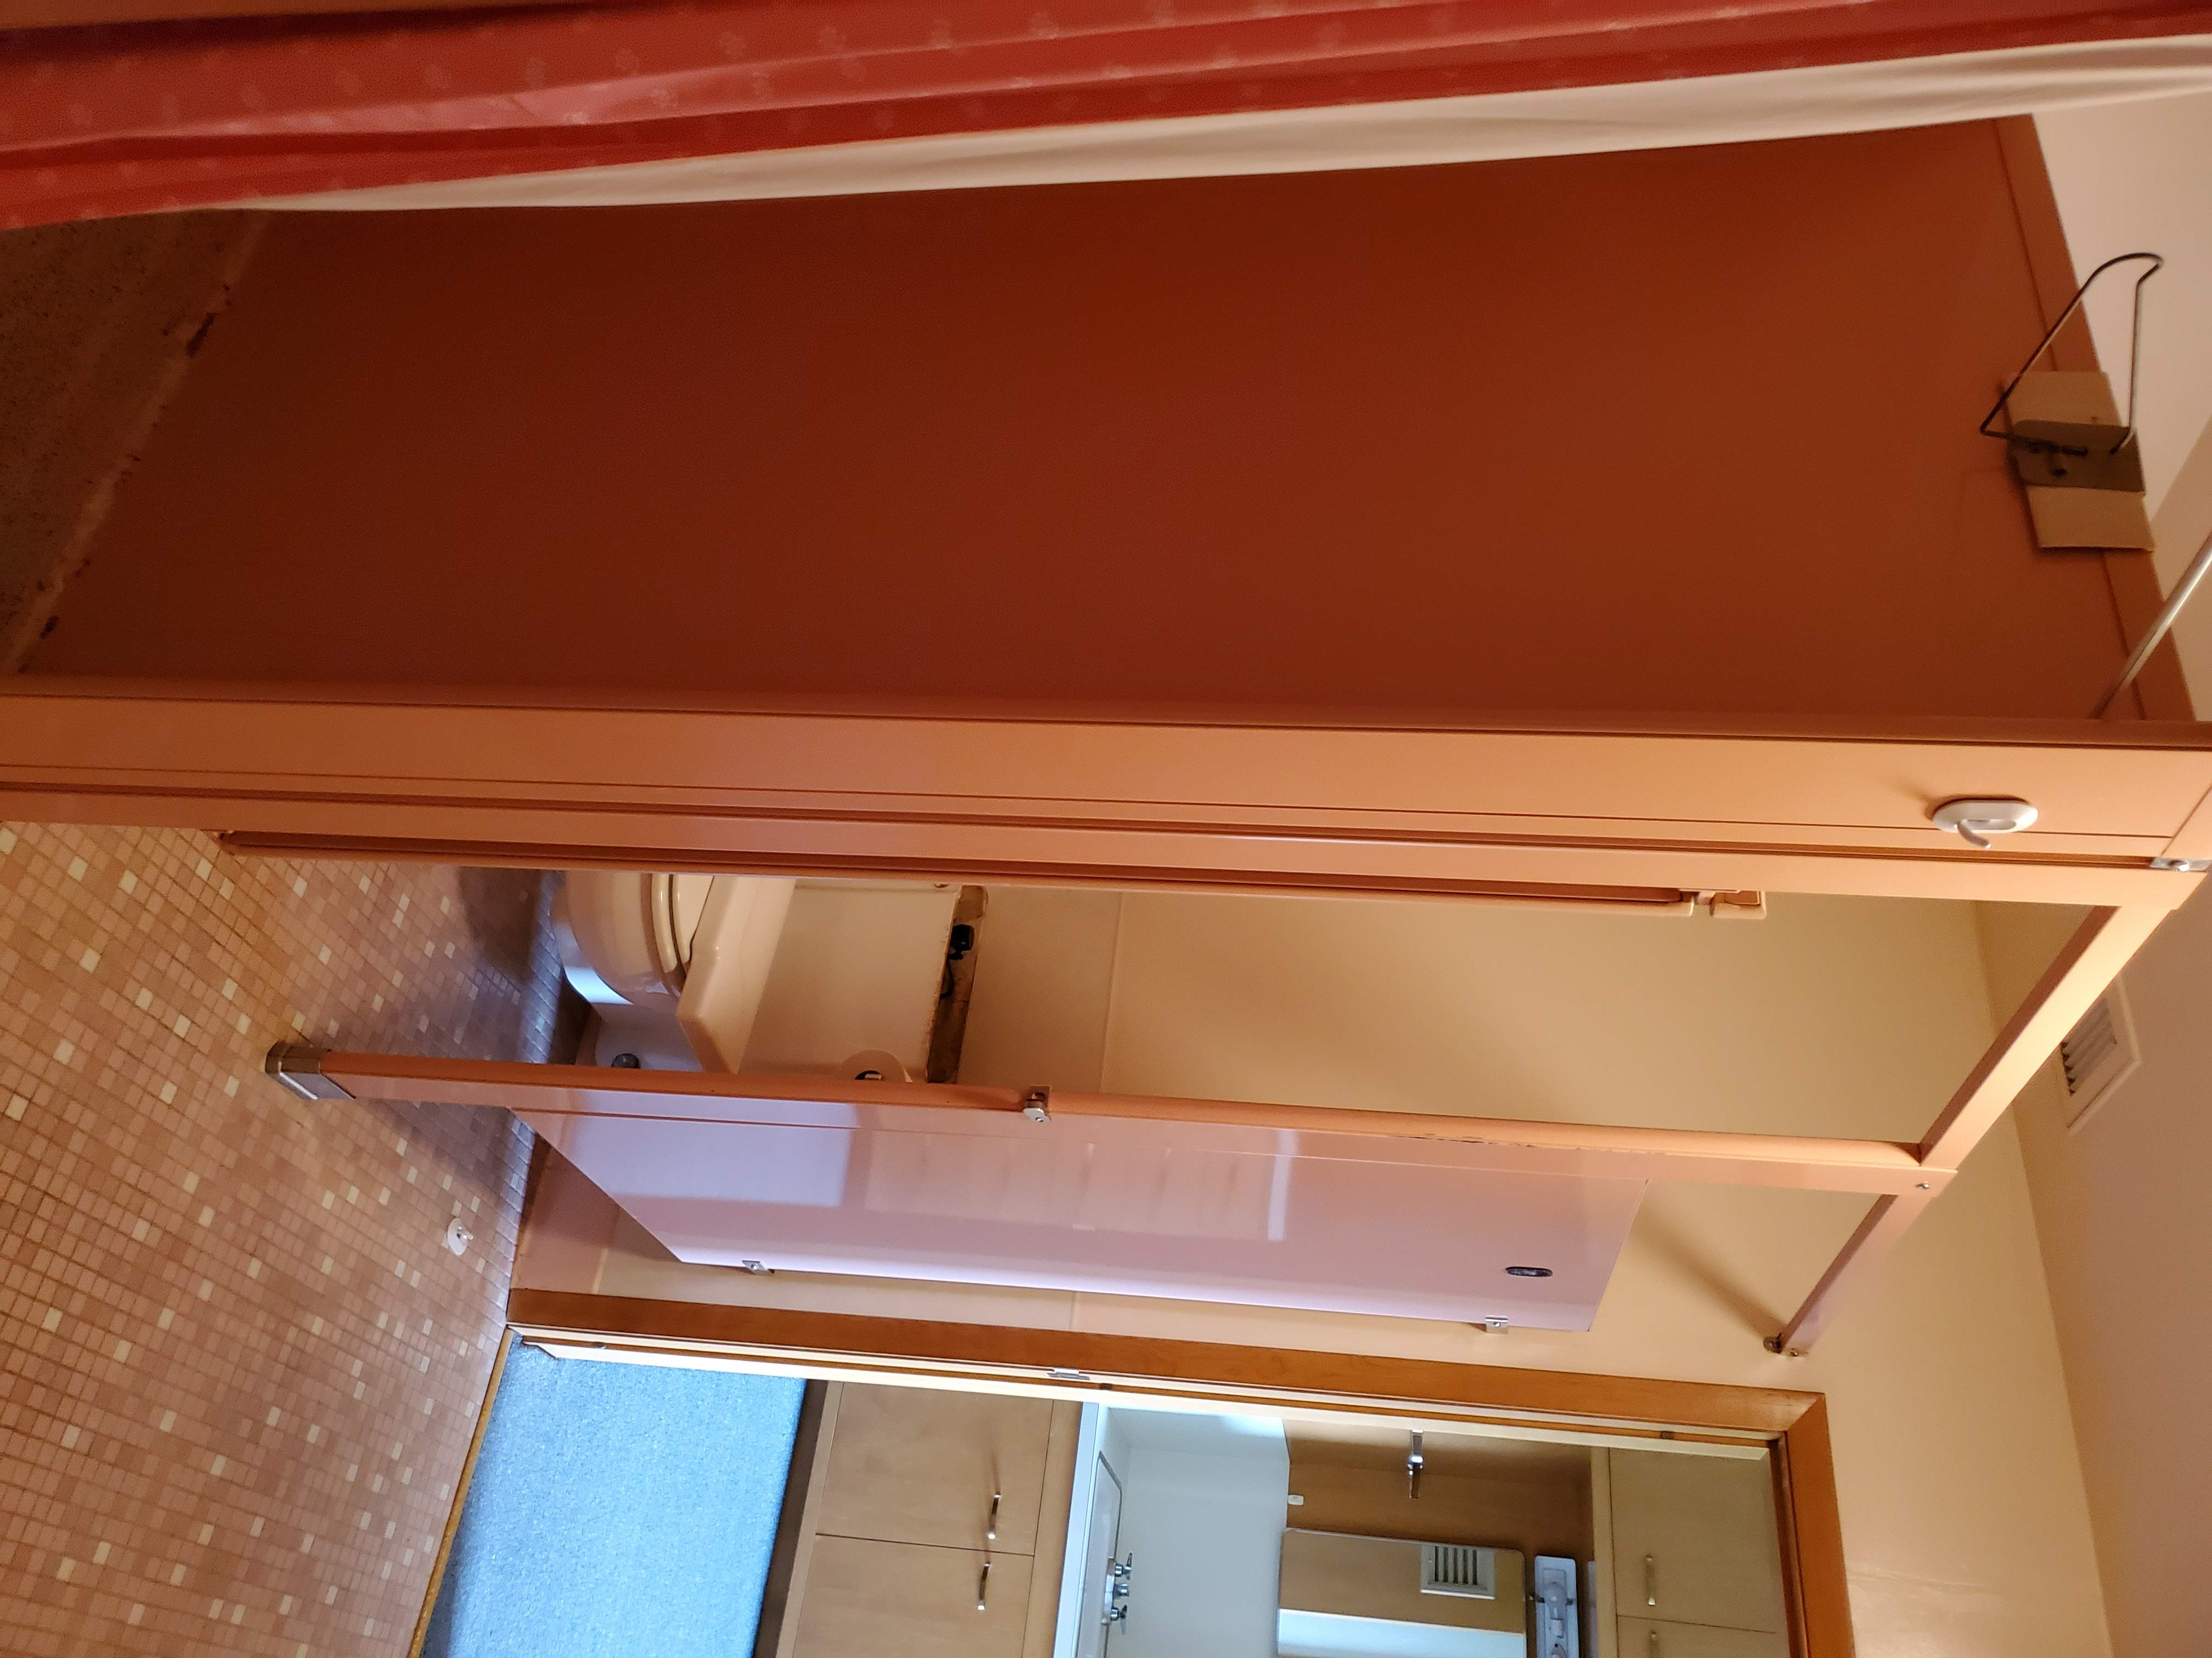
Community Renewal Events
When | Time | Where | What
9/7/19 | 6:00pm | RHS Sister Residnece | A tour and blessing of our new CEW home, Pizza Supper and CEW Jepardy
10/5/2019 | 6:00pm | Bahnaman’s 787Schatzie Ln | Campfire songs, hot dog and marshmallow roast and good old fellowship
11/8-10 |  | RHS Sister Residence | Women’s Lakeshore CEW
12/6 & 7 | TBD | Waldo Social Hall | Christmas Outreach
1/TBD | TBD | TBD | Hunger Simulation
2/21-2/23 |  | RHS Sister Residnece | Men’s Lakeshore CEW
3 |  |  | Any Ideas would be appreciated
4/7/2020 | 4:00 | Grand Church and hall | Soup and Stations

What are CREs? A Community Renewal Event is a group gathering, community event. They are a chance to rekindle friendships and build community with your CEW brother and sisters. Friends and family are welcome and need not have attended a weekend to participate. The lone exception is for Closings which are open only to those who have already made either a CEW or Cursillo.
Cut this section out and put it on your fridge, add the dates to your phone but most of all just come!

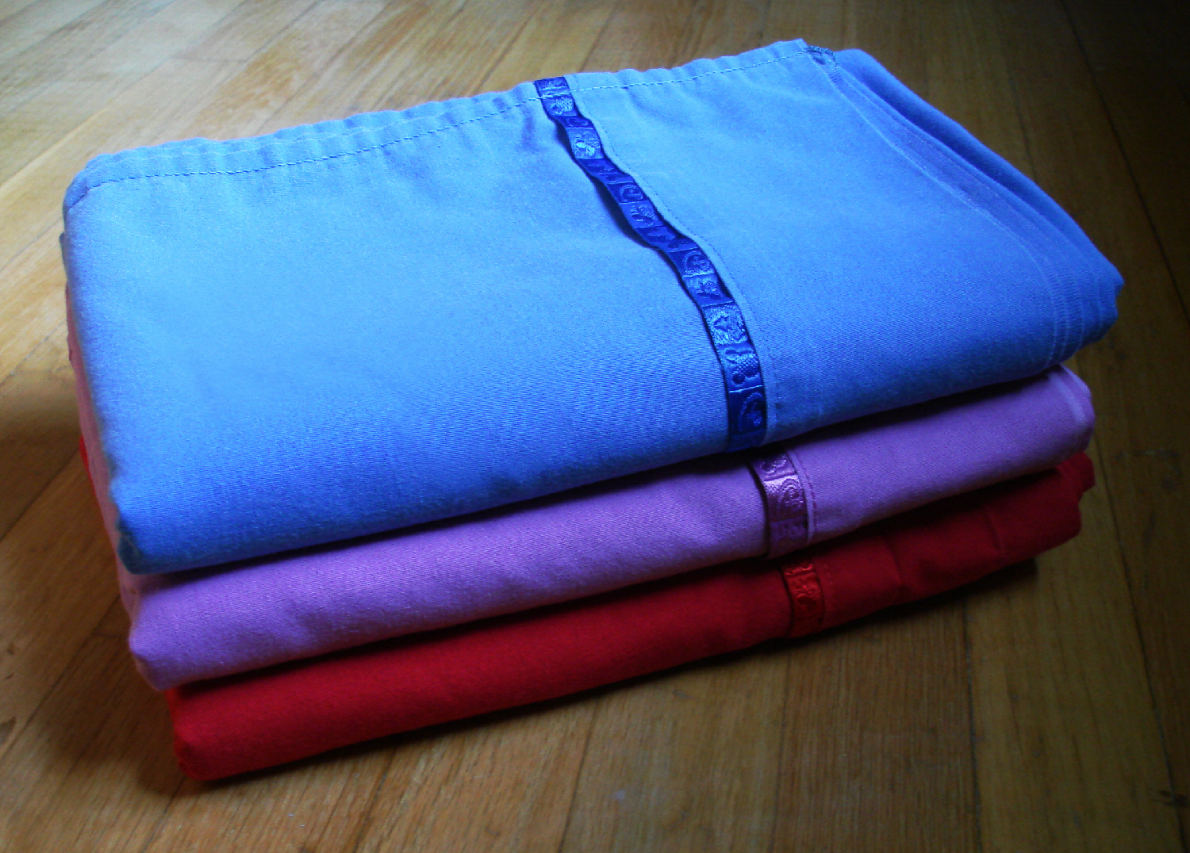

Wanted: twin sheet sets (1 flat 1 fitted), pillow cases, pillows and blankets (not your favorite Linus!). We need these for our new retreat facility. Sheets and blankets can be used in good shape but we prefer new pillows.
Call or text Dcn Rich @ 920-860-0478 for pickup

Enjoy the Rest of Your Summer!

